In our ABAP, we have three different ways we can divide numbers together. And this allows us to concentrate on the remainder of the actual integer division, and the standard division result with decimal places.

Standard Division

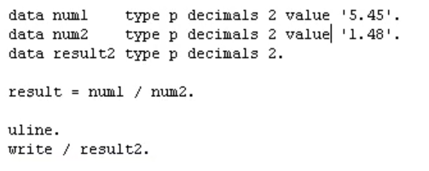

integer division

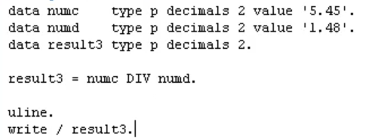

Now when we execute, we can see we're getting a result of 3. We're just getting the integer, the full number, not the decimal places.

Remainder Division

